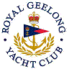 | Royal Geelong Yacht Club Inc.  Est 1859
Trophy Deed of Gift.

Trophy: | Cayzer Trophy
Presented by: | Cayzer Boat Company (Queenscliff)
Date: | 2014
For: | Concours d’ Elegance
Remarks / Revisions | For Motorboats
Click Here for a List of Winners

